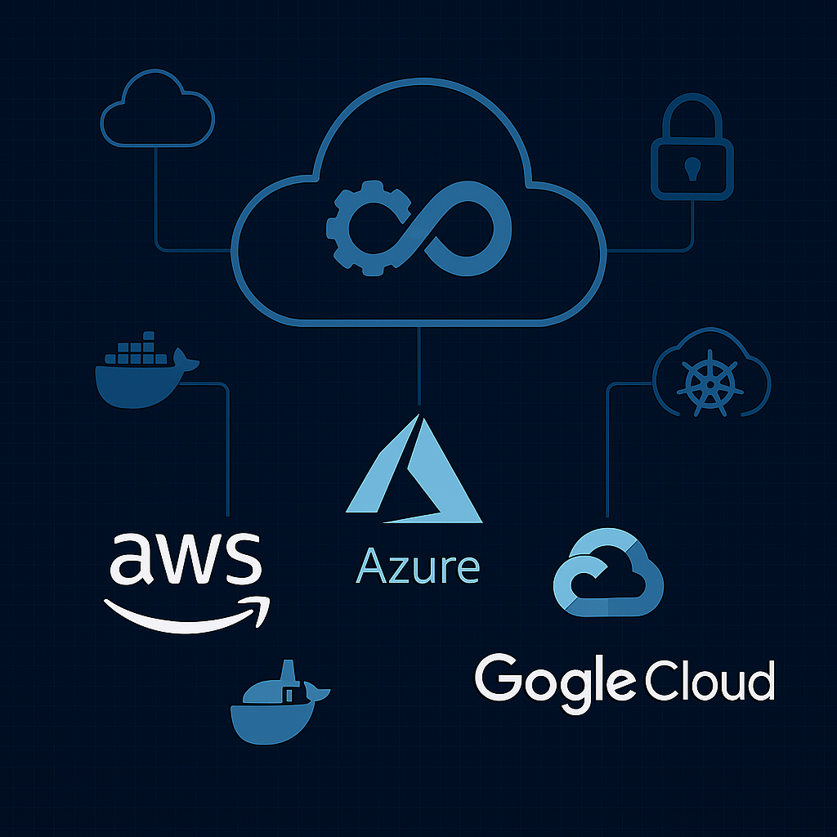  Multi-Cloud DevOps  Industry Ready professional curriculum | Abstract  The Multi-Cloud DevOps: Industry ‑Ready Professional Curriculum is a comprehensive, beginner‑friendly program designed to build strong foundational skills and real‑world engineering confidence. This curriculum blends cloud fundamentals, DevOps principles, automation workflows, and hands‑on multi‑cloud deployment practices across AWS, Azure, and Google Cloud. Each module is structured to remove overwhelm, reinforce clarity, and guide learners through practical, industry‑aligned scenarios. By integrating modern tools, CI/CD pipelines, containerization, infrastructure automation, and cloud‑native operations, the program prepares learners for real engineering environments and job‑ready responsibilities. The curriculum emphasizes step‑by‑step learning, practical labs, and professional best practices, enabling students to transition from zero experience to competent Multi‑Cloud DevOps engineers capable of contributing to enterprise‑scale systems.  Atul Matkawala  Multi-Cloud DevOps

Table of Contents
Course Overview 4
Duration: 4 Months | 120 hours | Beginner Job Ready 4
Program Highlights 4
What You Will Learn 5
Pre-requisites 6
Who This Course Is For 6
Tools You will use 7
Career Outcomes 9
You will be prepared for roles such as: 9
Step by Step Learning 10
PHASE 1 – FOUNDATIONS 10
DevOps Mindset & Career Orientation 10
Environment Setup & Virtualization 10
Linux Fundamentals 10
Networking Basics 10
YAML Fundamentals 10
PHASE 2 – CLOUD COMPUTING (AWS + AZURE + GCP) 11
Cloud Fundamentals 11
AWS Core Services (Hands-On) 11
Microsoft Azure Cloud Services (Hands-On) 12
Google Cloud Platform (Hands-On) 12
Cloud Billing and Cost optimization awareness 13
PHASE 3 – DEVOPS TOOLCHAIN 13
Git & Github 13
DevOps Architecture Blueprint 13
Build &CI/CD Tools 14
PHASE 4 — INFRASTRUCTURE AS CODE 15
Terraform Fundamentals 15
Working with Terraform 15
Modules 15
Terraform with AWS (Hands-On Labs) 15
Terraform State 16
Terraform Best Practices 16
PHASE 5 – MONITORING & OBSERVABILITY 16
Observability Concepts 16
Tools 16
Hands-On 17
PHASE 6 — CONFIGURATION MANAGEMENT 17
Ansible 17
PHASE 7 — CONTAINERS & ORCHESTRATION 17
Docker 17
Kubernetes 18
Helm & Tooling 18
PHASE 8 — GITOPS WITH ARGOCD (SIMPLIFIED) 18
ArgoCD Fundamentals 18
PHASE 9 — AWS CLOUD-NATIVE ORCHESTRATION 18
AWS ECS 18
AWS EKS 19
PHASE 10 — AZURE DEVOPS 19
Azure DevOps Overview 19
PHASE 11 – DEVOPS SECURITY BASICS 19
Security Essentials 19
PHASE 12 — TROUBLESHOOTING & DEBUGGING SKILLS 20
Troubleshooting 20
PHASE 13 – PYTHON BASICS (Absolute Essentials only) 20
PHASE 14 - FINAL CAPSTONE PROJECT 21
Enterprise-Grade Multi-Cloud DevOps Project 21
PHASE 14 — CAREER PREPARATION 21
Resume, Portfolio & Interview Prep 21
DevOps Interview Mindset 21

Course Overview

Duration: 4 Months | 120 hours | Beginner Job Ready
The Multi‑Cloud DevOps Engineering program provides a comprehensive learning path for beginners and professionals seeking DevOps and Cloud roles. Starting with Linux, networking, virtualization, YAML, and the DevOps mindset, it ensures students quickly gain technical comfort through hands-on practice. The course covers AWS core services, introduces Azure and GCP, and offers a multi-cloud perspective. Students learn essential DevOps tools like Git, Jenkins, Maven, Python, Terraform, and Ansible, with a strong focus on practical application.
Containerization and orchestration are taught using Docker, Kubernetes, Helm, and ArgoCD, along with awareness modules on AWS ECS/EKS and Azure DevOps. Monitoring skills are developed with Prometheus, Grafana, and Loki, and troubleshooting modules address common pipeline and cloud issues.
The capstone project lets students build a complete multi-cloud DevOps pipeline, serving as a portfolio piece for employers. Resume building, portfolio preparation, and interview coaching ensure readiness for various roles, including DevOps Engineer, Cloud Engineer, SRE, Build & Release Engineer, and Platform Engineer. This structured program transforms learners from entry level to job-ready through clear, practical skill-building.

Program Highlights
- 120 hours of structured, beginner-friendly learning
- Multi-cloud exposure (AWS, Azure, GCP)
- Hands-on labs in every module
- Real-world DevOps toolchain
- Kubernetes + GitOps + Terraform
- Capstone project for your portfolio
- Resume + interview preparation

What You Will Learn
- Core DevOps concepts, workflows, and real industry practices
- Linux fundamentals, server administration, and command-line mastery
- Networking essentials required for cloud and DevOps roles
- YAML fundamentals used across Kubernetes, Ansible, and CI/CD
- AWS core services with hands-on labs (EC2, S3, IAM, VPC, RDS, CloudWatch, etc.)
- Azure and GCP equivalents for multi-cloud awareness
- Git, GitHub, and branching strategies used in real teams
- CI/CD pipelines using Jenkins, GitHub Actions, and GitLab CI/CD
- Build automation using Maven
- Python scripting for automation and cloud tasks
- Infrastructure as Code using Terraform (VPC, EC2, modules, state)
- Configuration management using Ansible
- Monitoring and observability using Prometheus, Grafana, and Loki
- Docker containerization and Docker Compose for multi-container apps
- Kubernetes fundamentals: deployments, services, autoscaling, ingress
- Helm for packaging and deploying Kubernetes applications
- GitOps principles and ArgoCD for automated Kubernetes deployments
- Awareness of AWS ECS, AWS EKS, and Azure DevOps
- Troubleshooting pipelines, Kubernetes workloads, and cloud issues
- Building a complete multi-cloud DevOps project for your portfolio

Pre-requisites
This program is designed for complete beginners and career-switchers. No prior DevOps, cloud, or programming experience is required.
Recommended Prerequisites
- Basic computer literacy (installing software, navigating folders, using a browser)
- A laptop with 8 GB RAM minimum (16 GB recommended)
- Logical thinking and problem solving; willingness to learn
Optional (Nice to Have, Not Mandatory)
- Basic Linux commands
- Basic Git usage
- High-level understanding of cloud computing
All essential skills — Linux, Git, Python basics, cloud fundamentals, and DevOps tools — are taught from scratch during the course.

Who This Course Is For
This program is designed for anyone who wants to build a strong, job-ready foundation in DevOps and cloud engineering — regardless of their starting point. It is especially ideal for:
- Fresh graduates who want to enter the IT industry with in-demand, practical skills
- Career-switchers from non-IT or unrelated domains looking to transition into DevOps
- Software testers, support engineers, and system administrators aiming to move into cloud or DevOps roles
- Developers who want to understand CI/CD, automation, and cloud-native workflows
- IT professionals seeking to upgrade their skills with modern DevOps tools and multi-cloud knowledge
- Anyone who wants a structured, guided path to becoming a DevOps Engineer, Cloud Engineer, or SRE
Whether you are starting from scratch or looking to strengthen your existing skills, this course provides a clear, confidence-building roadmap to help you grow into a capable, industry-ready DevOps professional.

Tools You will use
Throughout this program, you will work hands-on with the most widely used DevOps, Cloud, and Automation tools in the industry. These tools form the backbone of modern infrastructure, CI/CD pipelines, cloud deployments, and container-oriented workflows.
Cloud Platforms
- Amazon Web Services (AWS)
- Microsoft Azure
- Google Cloud Platform (GCP)
Version Control & Collaboration
- Git
- GitHub
- GitLab
Build & CI/CD
- Maven
- Jenkins
- GitHub Actions
- GitLab CI/CD
- SonaType Nexus
- SonarQube
Infrastructure as Code
- Terraform
Configuration Management
- Ansible
Containers & Orchestration
- Docker
- Docker Compose
- Kubernetes
- Helm
- ArgoCD (GitOps)
Monitoring & Observability
- Prometheus
- Grafana
- Loki
Scripting & Automation
- Python (DevOps-focused essentials)
- Bash & Linux command-line tools
Add-ons
- Nginx
- Apache

Career Outcomes
By the end of this program, you will be equipped with the skills, confidence, and portfolio needed to step into a variety of high-growth DevOps and cloud roles. You will be able to:
- Build and manage CI/CD pipelines used in real engineering teams
- Deploy and operate applications on AWS, Azure, and GCP
- Automate infrastructure using Terraform and Ansible
- Work with Docker, Kubernetes, and GitOps workflows
- Monitor and troubleshoot production-grade systems
- Collaborate effectively with developers, QA, and cloud teams
- Present your DevOps projects confidently in interviews
- Demonstrate hands-on experience through a complete multi-cloud capstone project

You will be prepared for roles such as:
- DevOps Engineer (0–3 years)
- Cloud Engineer
- Site Reliability Engineer (Junior SRE)
- Build & Release Engineer
- Platform Engineer (Entry-level)
- Infrastructure Engineer
- Automation Engineer

Step by Step Learning

PHASE 1 – FOUNDATIONS

DevOps Mindset & Career Orientation
- DevOps culture, workflows, and real industry pipelines
- Roles: Dev, QA, Ops, Cloud, SRE
- DevOps career roadmap

Environment Setup & Virtualization
- VS Code, Git, CLI tools
- VirtualBox & Vagrant
- Local development environment setup

Linux Fundamentals
- Commands, permissions, SSH
- Processes, services, systemd
- Server administration essentials

Networking Basics
- IP, DNS, ports, firewalls
- Subnets & CIDR

YAML Fundamentals
- Syntax, indentation
- YAML in DevOps tools (K8s, Ansible, CI/CD)

PHASE 2 – CLOUD COMPUTING (AWS + AZURE + GCP)

Cloud Fundamentals
- Regions, AZs, global infrastructure
- IaaS, PaaS, SaaS
- Shared responsibility model

AWS Core Services (Hands-On)
- IAM (Identity and Access Management)
- EC2 (Elastic Compute Cloud)
- EBS (Elastic Block Storage)
- S3 (Simple Storage service)
- VPC (Virtual Provide Cloud)
- ELB (Elastic Load Balancer)
- Auto Scaling
- RDS (Relational Database Service)
- Route 53
- CloudWatch
- Lambda
- AWS CLI, CloudShell
- SSL Certificates (ACM)

Microsoft Azure Cloud Services (Hands-On)
- Azure AD
- Azure VM
- Disk Storage
- Blob Storage
- Vnet (Azure Virtual Networking)
- Load Balancer/ App Gateway
- Azure Autoscale
- Azure SQL Database
- Azure DNS
- Azure Monitor
- Azure Functions
- Azure CLI & Azure CloudShell
- Azure SSL Certificates

Google Cloud Platform (Hands-On)
- Cloud IAM
- Compute Engine
- Persistent Disk
- Cloud Storage
- VPC
- Cloud Load Balancing
- Autoscaler
- Cloud SQL
- Cloud DNS
- Cloud Monitoring
- Cloud Shell
- Cloud Functions
- Google Managed SSL Certs

Cloud Billing and Cost optimization awareness
- EC2 cost basics
- S3 storage classes
- Load balancer cost traps
- Rightsizing basics

PHASE 3 – DEVOPS TOOLCHAIN

Git & Github
Git Essentials
- What is version control
- Local Git repository
- git init, git add, git commit
- .gitignore basics
GitHub Essentials
- Git branching strategies (Git Flow, Trunk-based)
- Pull requests, issues
- GitHub workflows

DevOps Architecture Blueprint
- Code → Build → Test → Artifact → Deploy → Monitor
- Where Git fits
- Where CI fits
- Where CD fits
- Where IaC fits
- Where containers & K8s fit
- Where monitoring fits

Build &CI/CD Tools

MAVEN Build Tools
- Build lifecycle
- Packaging & artifacts

Jenkins CI/CD
- Jenkins setup
- Scripted & Declarative pipelines
- Master/Agent architecture
- Sonatype Nexus integration
- SonarQube/SonarScanner integration

GitHub Actions
- Workflows
- Runners
- Secrets
- Security scans

GitLab CI/CD
- Pipelines
- Stages
- Docker integration

PHASE 4 — INFRASTRUCTURE AS CODE

Terraform Fundamentals
- What is IaC
- Why Terraform
- Install Terraform
- Providers & Resources
- Basic Syntax
- Your First Script (main.tf)

Working with Terraform
- Plan, Apply, Destroy
- Terraform Registry
- Variables & Outputs
- Breaking main.tf into variables.tf & outputs.tf
- Terraform Console

Modules
- What are Modules
- Creating your first module
- Using public modules (simple example)
- Root module structure

Terraform with AWS (Hands-On Labs)
- Configure AWS credentials
- Create S3 bucket
- Create EC2 instance
- User Data & template file
- Build a reusable module
- VPC, Subnets, IGW, Route Tables
- Security Groups
- Final VPC + EC2 project

Terraform State
- What is state
- Why state matters
- Remote state (concept only)

Terraform Best Practices
- Folder structure
- Naming conventions
- Reusable modules
- Version control for Terraform

PHASE 5 – MONITORING & OBSERVABILITY

Observability Concepts
- Metrics, logs, traces

Tools
- Prometheus
- Grafana
- Loki

Hands-On
- PromQL
- Dashboards & alerts
- Slack integrations

PHASE 6 — CONFIGURATION MANAGEMENT

Ansible
- Ad-hoc commands
- Modules, playbooks
- Variables, loops, conditions
- Templates, handlers, roles
- AWS automation

PHASE 7 — CONTAINERS & ORCHESTRATION

Docker
- Images, containers
- Volumes, networks
- Docker Compose
- Container registries (ECR, ACR, GCR, Docker Hub)

Kubernetes
- Cluster setup
- Pods, Deployments, Services
- Autoscaling
- Ingress
- ConfigMaps & Secrets

Helm & Tooling
- Helm charts
- Lens
- AI-assisted Helm

PHASE 8 — GITOPS WITH ARGOCD (SIMPLIFIED)

ArgoCD Fundamentals
- GitOps principles
- ArgoCD architecture
- Application manifests
- Sync policies
- Simple GitOps deployment

PHASE 9 — AWS CLOUD-NATIVE ORCHESTRATION

AWS ECS
- ECS vs EKS
- Task definitions
- Services
- Fargate concept & Demo

AWS EKS
- What is EKS
- Node groups
- Simple deployment demo

PHASE 10 — AZURE DEVOPS

Azure DevOps Overview
- Repos
- Pipelines
- Boards
- Artifacts
- Multi-cloud CI/CD awareness

PHASE 11 – DEVOPS SECURITY BASICS

Security Essentials
- IAM least privilege
- SSH keys
- Secrets management basics
- HTTPS certificates
- Container security basics

PHASE 12 — TROUBLESHOOTING & DEBUGGING SKILLS

Troubleshooting
- Reading logs
- Debugging pipelines
- Debugging Kubernetes pods
- Common AWS mistakes
- Thinking like an SRE

PHASE 13 – PYTHON BASICS (Absolute Essentials only)
- What is Python & why DevOps engineers use it
- Running Python scripts (.py files)
- Variables
- Data types (string, int, float, bool)
- Basic operators
- Input/output
- Comments & readability

PHASE 14 - FINAL CAPSTONE PROJECT

Enterprise-Grade Multi-Cloud DevOps Project
- CI/CD (Jenkins or GitHub Actions)
- Terraform IaC
- Kubernetes deployment
- GitOps with ArgoCD
- Monitoring with Grafana
- Deployment on AWS/GCP
- Documentation + Resume-ready portfolio

PHASE 14 — CAREER PREPARATION

Resume, Portfolio & Interview Prep
- DevOps resume writing
- How to talk about projects
- Scenario-based interview questions
- Mock interviews

DevOps Interview Mindset
- How to explain tools without jargon
- How to talk about projects
- How to answer scenario questions
- How to avoid over-explaining

